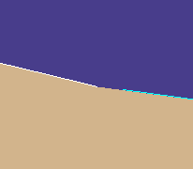 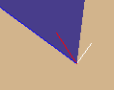

In pic 1, the green line is the path of the particle. It is very close to shore and happens to go nearly parallel to shore. It slams into the white edge and, for slippery shore purposes, backs off so that it is all but guaranteed to be in water. From there, it will go parallel to the edge it slammed into.

The problem is that when it backed off, due to rounding problems, the point was classified as land. That’s where I was yesterday AM.

To fix this, I decided “get this baby away from land!” So I went perpendicular to the landfall out towards sea. That every edge has “land-to-the-left” made this pretty easy. A few sines and cosines perhaps, and a little rotational geometry, but all of that is routine within the Simulator and Planner.

But that screwed up in the second picture. The red particle hit the blue edge and bounced off perpendicular to the blue edge, as shown by the white. Land again!

This case is fixed by repeating the second process: Does the white land me on land again? If so, repeat the process; Go from the original position (left side of red) towards top right of white, find which edge blocked, go to sea from that point, etc.. If after 3 times, give up and the new position of this particle is just the old position.

I thought slippery shore had been pretty well tested; rivers are slippery and the Columbia and Mississippi have lots of nooks and crannies to mess things up.

Obviously, these are very unusual cases. But we run a lot of particles and Guy’s case near Vancouver Island is pretty intricate.

See the movie for a happy ending.

